Rhytisma acerinum (tar-spot fungus) as a biological indicator of pollution
It has been known for a long time that the fungus Rhytisma acerinum, which causes leaf disease known as tar spot (Fig. 1) of sycamore (Acer pseudoplatanus), seems to be sensitive to atmospheric pollutants (Bevan & Greenhalgh 1976). The actual mechanism of sensitivity is not understood, although it is generally accepted that the major pollutant involved is sulphur dioxide. The annual average concentration of atmospheric sulphur dioxide in the air can be estimated by calculating the number of tar spots per unit area of leaf surface.
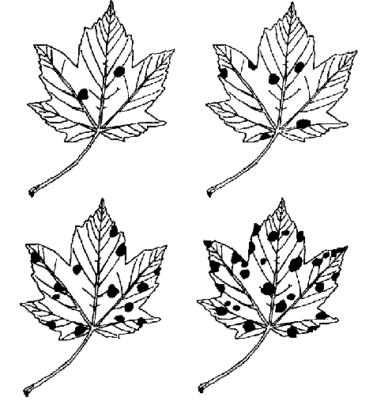
Figure 1. Sycamore leaves infected with Rhytisma acerinum showing the appearance of leaf spots and different degrees of infection.

Draw around on cm graph paper, the sycamore leaf that you have been given (which were collected from the Peak District) and work out the area of the leaf in cm². Count the number of tar spots per leaf.
The number of tar spots per 100 cm² of leaf is the Tar Spot Index (TSI) – calculate this and use it to estimate the concentration of sulphur dioxide in the air from Table 1 below.

Table 1. Inverse relationship between the severity of the disease as measured by tar spot index (TSI) and increasing levels of sulphur dioxide.
TSI ranges | Estimated annual average sulphur dioxide levels (microgram/m³)
0 | >85
0-0.47 | 55-85
0.47-0.76 | 40-55
0.76-2.1 | 25-40
>2.1 | <25
Congratulations! You have used a biological indicator to find the atmospheric concentration of sulphur dioxide at a location in the Peak District.

Reference
Bevan, R. J. & Greenhalgh, G. M. (1976) Rhytisma acerinum as a biological indicator of pollution. Environmental Pollution 10, 271-285.

